A. Select one of the provided scenarios and complete the following:
1. Describe a business problem that can be solved with a database solution and is in alignment with the chosen scenario.
We want to determine what the average price of the products overall are, the most common ingredients in the products, and those who have dry or normal skin. This is give us an idea on the average cost of these cosmetics products, the most preferred ingredients in them and if people who use those products are those who have abnormal skin conditions.
2. Justify why a NoSQL database solution will solve the identified business problem.
We are working with a non-relational database meaning that this database doesn’t have a strict structure. In SQL the data is arranged in an array with columns and rows and primary and foreign keys can relate the data. The schema is flexible and dynamic in a non-relational database. We are give a JSON file which is for document-orientated NoSQL database.
3. Identify a NoSQL database type to solve the identified business problem.
We are using MongoDB which is a Document-Orientated NoSQL Database
4. Explain how the business data will be used within the database solution.
We will import the data into the MongoDB Compass which is then used to analyze the data to run three queries that can answer the business question.
B. Discuss how the proposed database design addresses scalability concerns, including strategies that align with the chosen scenario.
MongoDB enhances scalability and performance through horizontal scaling with sharding, indexing for faster queries, and schema flexibility. Unlike traditional SQL databases that depend on vertical scaling by adding more CPU and RAM to a single server, MongoDB uses sharding to distribute data across multiple servers.
This ensures efficient handling of large datasets and high traffic loads. Additionally, indexing optimizes query performance by reducing search time and preventing full collection scans. The Ingredients Text Index enables efficient ingredient-based searches, the Price Index speeds up average price computations, and the Skin Type Index enhances queries that count products by skin type.
These optimizations significantly reduce query execution time and improve system responsiveness. Furthermore, MongoDB’s schema flexibility allows products to have different attributes without requiring database structure modifications, making it easy to accommodate frequent updates and adapt to evolving business needs. This combination of scalability, performance optimization, and adaptability makes MongoDB an ideal choice for dynamic and data-intensive applications.
C. Outline the privacy and security measures that should be implemented in the proposed database design.
To enhance security, authentication is enabled to restrict database access to authorized users. Role-Based Access Control ensures users have only the minimum necessary permissions. Very good passwords and authentication are enforced to prevent unauthorized access. Additionally, monitoring for activity logging and failed login monitoring help detect security breaches and track critical data changes. These measures strengthen database security and ensure compliance with best practices.
Part 2: Implementation
D. Implement the proposed database design in the WGU Virtual Lab environment by completing the following:
1. Write script to create a database instance named “D597 Task 2” using the appropriate query language, based on your design in Part 1. Provide a screenshot showing the script and the database instance in the platform.
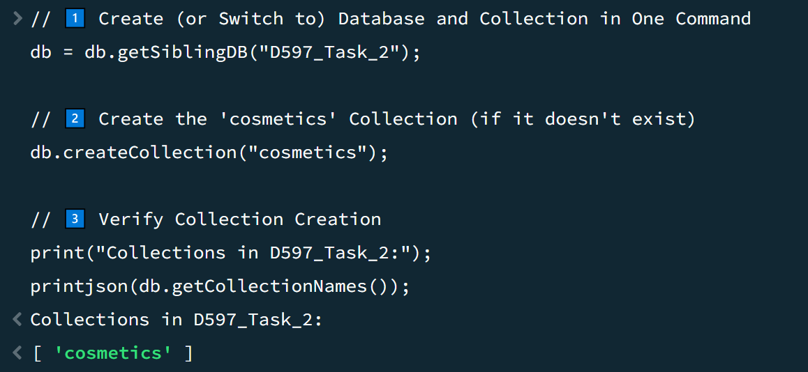
2. Write script to insert or map the data records from the chosen scenario JSON files into the database instance. Provide a screenshot showing the script and the data correctly inserted or mapped into the database.
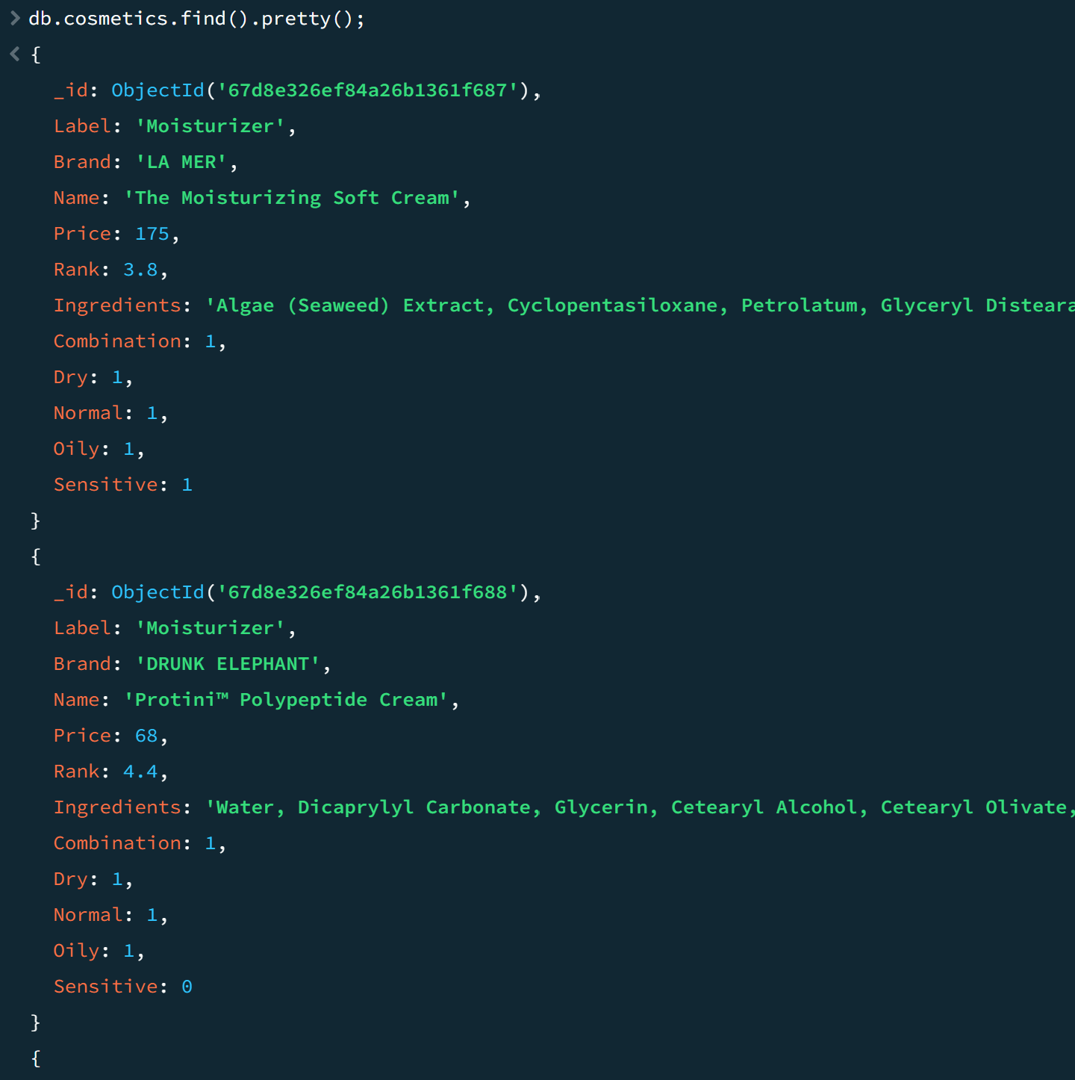
3. Write script for three queries to retrieve specific information from the database that will help to solve the identified business problem. Provide a screenshot showing the script for each query and each query successfully executed.
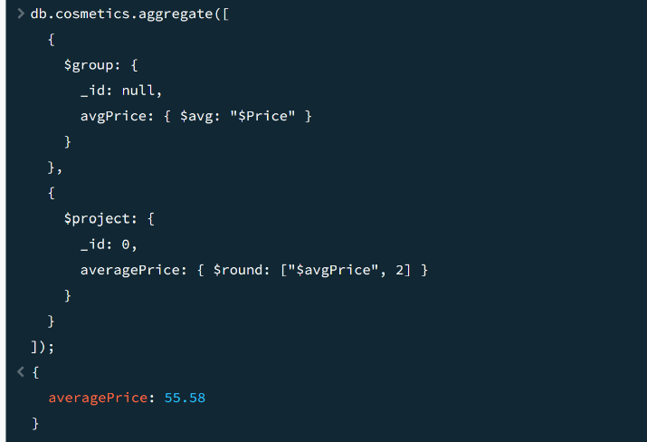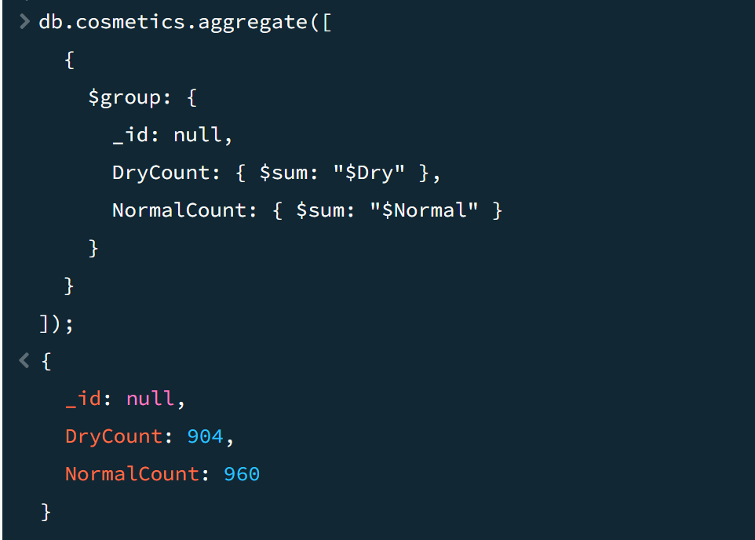
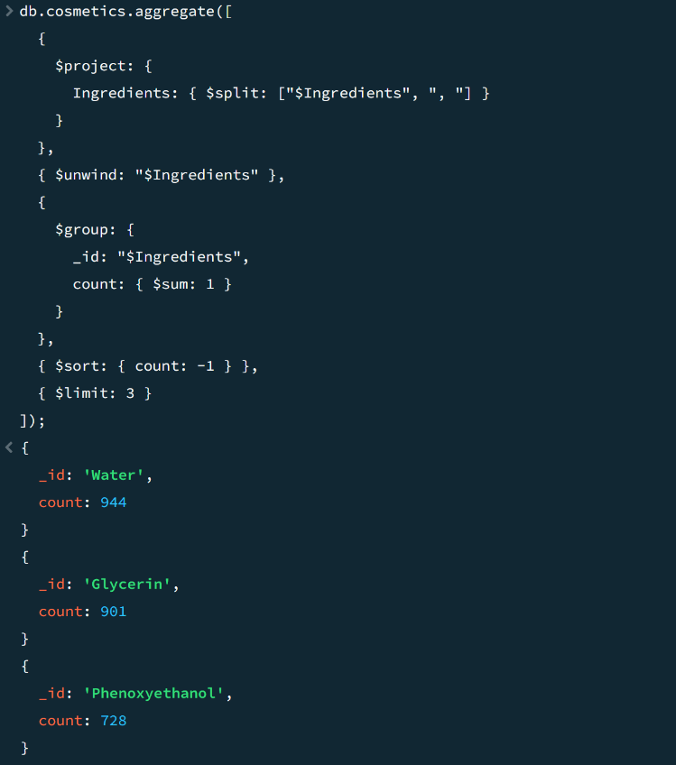
4. Apply optimization techniques to improve the run time of your queries from part D3, providing output results via a screenshot.
